JIGSAW JAMBOREE!
500 pc PUZZLE RACE CONTEST
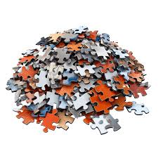
Race solo or in teams ☺
Monday, March 30, 2026 1:00 pm
CURTIS PUBLIC LIBRARY
Please register by March 20 Prizes! Refreshments! Fun!

